Visualization of Formula One Career Results
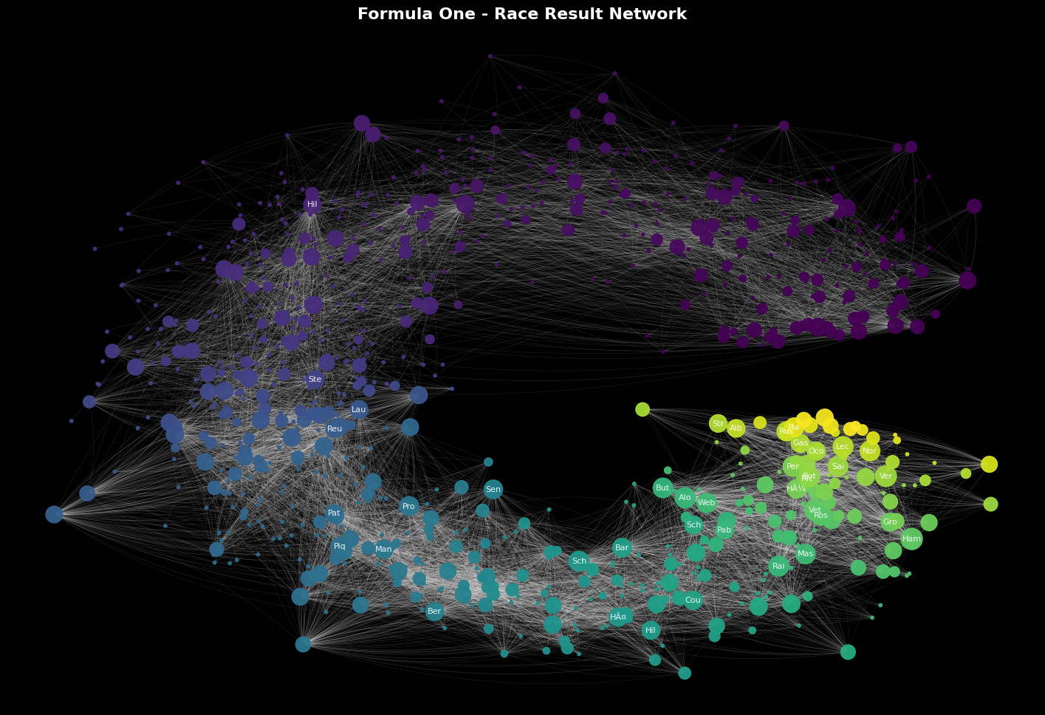
Fig. 1: Formula One Career Results
Introduction
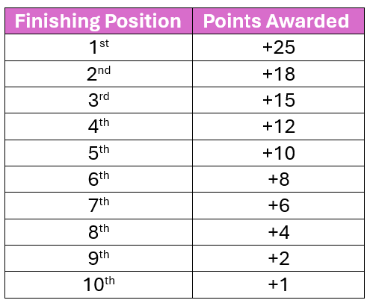
Formula One is considered the highest class of international in open-wheel single-seat racing. Having just celebrated the 75th anniversary of the sport, the sport has had consistent formatting of 20 drivers and 10 teams (2 drivers per team) with a varying number of races per season. However, the 2026 season introduced an 11th team, making it a total of 22 drivers per season. Race results are based on finishing position in the final lap of a race, which can vary depending on the circuit, as circuit laps vary in distance, total lap count is adjusted to maintain a consistent of ~305 km per race. Based on the finishing position of each race, drivers are awarded points, which also contributes to the Team points. At the end of the racing season (usually early December) two championships are decided, the Drivers Championship and the Constructors Championship. The Drivers Championship determines which individual driver scored the most points throughout the racing season, while the Constructors Championship determines which Team scored the most points.
Dataset
The Formula One Race Data[1] used for this project was sourced through Kaggle. The dataset contains 14 different tables with data ranging from seasons beginning in 1950 and through 2025. This data does not contain the current (2026) season and therefore does not reflect the addition of an 11th team or the additional 2 drivers. With the use of Microsoft Access, I combined 5 of the available tables (Results, Drivers, Race Status, Races, Lap Times) to create a consolidated table of 27,304 records. Instances of a race status outside of “Finished” were not removed, as the main observation of this project is the overall race career results and a race status of “retired” or “DNF (Did Not Finish)” still contribute to a driver’s overall career performance.
Visualization and Analysis
In figure 1, each node is representative of a driver’s initial debut, with earliest being represented in purple and latest in yellow. The edges depict race results of each driver; the connection is linked to the driver that finished in the position directly behind them (ex. Driver 1 finished 1st -> Driver 2 finished 2nd). Additionally, nodes are clustered based on common links, so if Driver 1 and Driver 2 finish next to each other often, they will be depicted closer on the graph, this explains the nodes that tend to float far away from the central graph. These nodes are Drivers that are not finishing next to any common drivers and usually have few links indicating there may be inconsistent or poor performance. Node size is determined by a driver’s total career points, so drivers that have had more successful careers will be larger.
Although there will be some links between different colored nodes (dark purple/ light purple, teal/yellow), there is a distinct gap between purple nodes and yellow nodes due to the average career length of a Driver consisting of [] years, thus making a connection between the two impossibles.
Figures 2 depicts the top 40 drivers with the longest careers. This was calculated based on the year each driver debuted and their final season. Figure 3 shows each of the top 40 drivers and their longest connection. This is another method of visualizing the length of a career in the sport. Especially in the earlier years (purple) we see much longer connections, thus longer career length. As the sport has grown, there is an increase incoming athletes and young talent, therefore career length goes down as we approach the latest season.

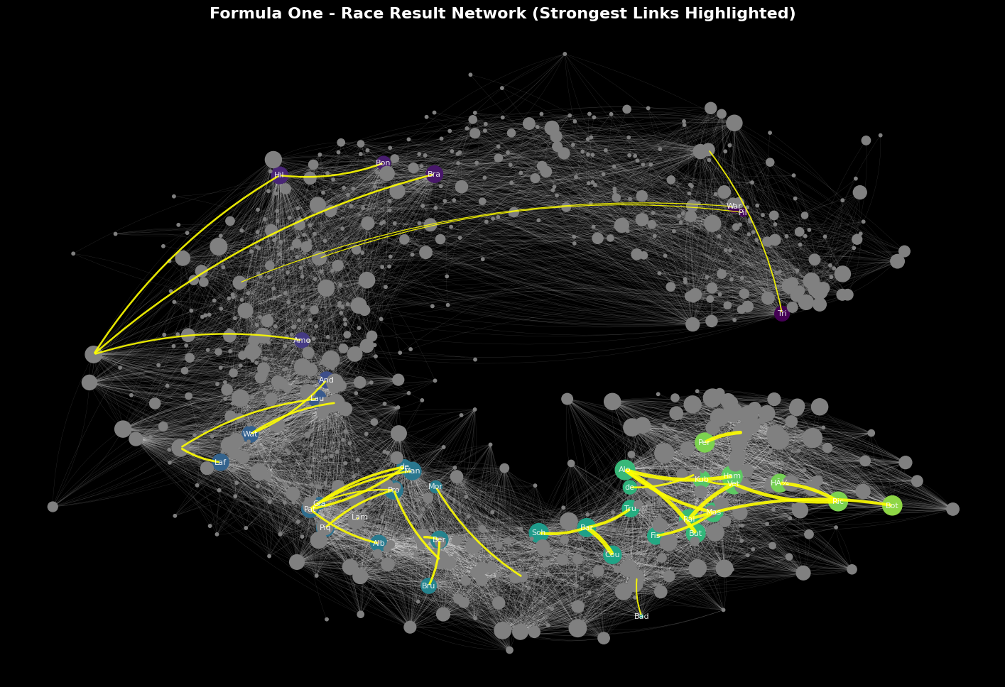
Fig. 2: Top 40 Drivers With the Longest Links
From the top 40 drivers we are also able to compare the career points earned. From Fig. 4 we see those newer drivers, such as HAM (Hamilton) have earned more career points than most of the older drivers combined
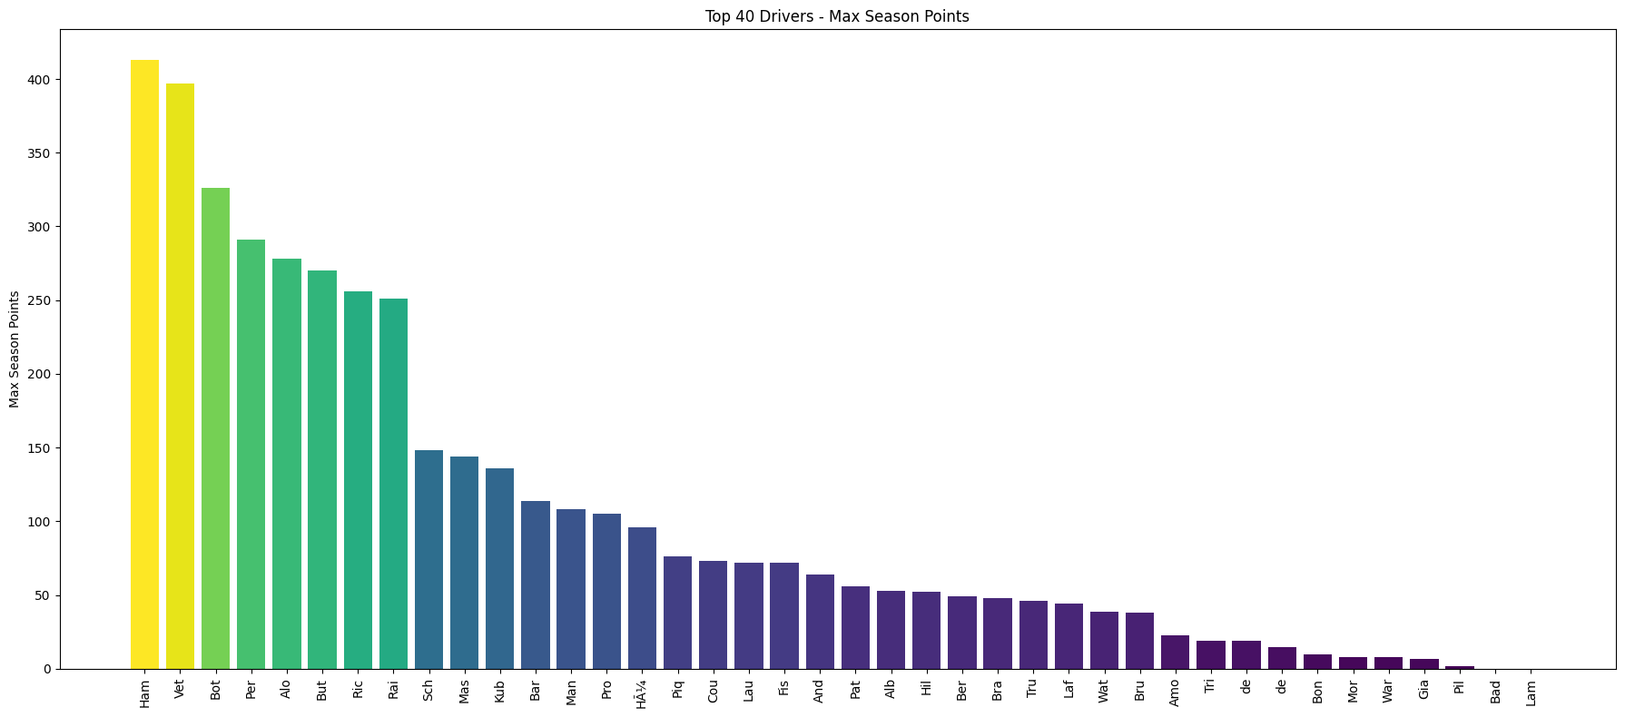
Fig. 3: Lifetime Points of Top 40 Longest Career Drivers
Conclusion
As we approach the year 2025, we see an increase in node size indication that general performance of drivers is increasing. This is likely an indication of increased talent but also an increase in machinery capabilities. This is a sport that is heavily dependent on technology so it makes sense that there would be an increase in performance along with an increase in machinery.

